Lab 15 - CCNA: Introduction to Networks
Packet Tracer- Configure and Verify NTP
Topology
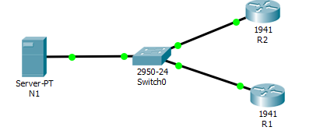
Addressing Table
Device | Interface | IP Address | Subnet Mask
N1 | NIC | 209.165.200.225 | 255.255.255.0
R1 | G0/0 | 209.165.200.226 | 255.255.255.0
R2 | G0/0 | 209.165.200.227 | 255.255.255.0
Objectives
In this activity, you will configure NTP on R1 and R2 to allow time synchronization.
Background / Scenario
Network Time Protocol (NTP) synchronizes the time of day among a set of distributed time servers and clients. While there are a number of applications that require synchronized time, this lab will focus on correlating events that are listed in the system log and other time-specific events from multiple network devices. NTP uses the User Datagram Protocol (UDP) as its transport protocol. All NTP communications use Coordinated Universal Time (UTC).
An NTP server usually receives its time from an authoritative time source, such as an atomic clock attached to a time server It then distributes this time across the network. NTP is extremely efficient; no more than one packet per minute is necessary to synchronize two machines to within a millisecond of each other.
Step 1: NTP Server
a. Server N1 is already configured as the NTP Server for this topology. Verify its configuration under Services > NTP.
b. From R1, ping N1 (209.165.200.225) to verify connectivity. The ping should be successful.
c. Repeat the ping to N1 from R2 to verify connectivity to N1.
Step 2: Configuring the NTP Clients
Cisco devices can be configured to refer to an NTP server to synchronize their clocks. This is important to keep time consistent among all devices. Configure R1 and R2 as NTP clients so their clocks are synchronized. Both R1 and R2 will use N1 server as their NTP server. To configure R1 and R2 as an NTP clients, issue the commands below:
a. Use the ntp server command to specify an NTP server, as shown below:
R1# conf t
R1(config)# ntp server 209.165.200.225

R2# conf t
R2(config)# ntp server 209.165.200.225
b. Check the clock on R1 and R2 again to verify that they are synchronized:
R1# show clock
*12:02:18:619 UTC Tue Dec 8 2015

R2# show clock
*12:02:20:422 UTC Tue Dec 8 2015

Note: When working on physical routers, allow a few minutes before R1 and R2 clocks are synchronized.

Answer Q1 on Answer Sheet

Packet Tracer- Configuring Syslog and NTP
Topology
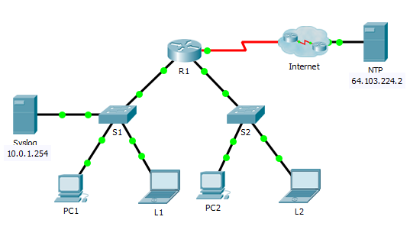
Objectives
Part 1: Configure Syslog Service
Part 2: Generate Logged Events
Part 3: Manually Set Switch Clocks
Part 4: Configure NTP Service
Part 5: Verify Timestamped Logs
Scenario
In this activity, you will enable and use the Syslog service and the NTP service so that the network administrator is able to monitor the network more effectively.
Part 1: Configure Syslog Service
Step 1: Enable the Syslog service.
a. Click Syslog, then Services tab.
b. Turn the Syslog service on and move the window so you can monitor activity.
Step 2: Configure the intermediary devices to use the Syslog service.
a. Configure R1 to send log events to the Syslog server.
R1(config)# logging 10.0.1.254
b. Configure S1 to send log events to the Syslog server.
c. Configure S2 to send log events to the Syslog server.
Part 2: Generate Logged Events
Step 1: Change the status of interfaces to create event logs.
a. Configure a Loopback 0 interface on R1 then disable it.
b. Turn off PC1 and PC2. Turn them on again.
Step 2: Examine the Syslog events.
a. Look at the Syslog events. Note: All of the events have been recorded; however, the time stamps are incorrect.
Do Q2 on Answer sheet before moving to Step 2b
b. Clear the log before proceeding to the next part.
Part 3: Manually Set Switch Clocks
Step 1: Manually set the clocks on the switches.
Manually set the clock on S1 and S2 to the current date and approximate time. An example is provided.
S1# clock set 11:47:00 July 10 2013
Step 2: Enable the logging timestamp service on the switches.
Configure S1 and S2 to send its timestamp with logs it sends to the Syslogserver.
S1(config)# service timestamps log datetime msec
Part 4: Configure NTP Service
Step 1: Enable the NTP service.
In this activity, we are assuming that the NTP service is being hosted on a public Internet server. If the NTP server was private, authentication could also be used.
a. Open the Services tab of the NTP server.
b. Turn the NTP service on and note the date and time that is displayed.
Answer Q3 on Answer Sheet
Step 2: Automatically set the clock on the router.
Set the clock on R1 to the date and time according to the NTP server.
R1(config)# ntp server 64.103.224.2
Step 3: Enable the logging timestamp service of the router.
Configure R1 to send its timestamp with the logs that it sends to the Syslogserver.
Part 5: Verify Timestamped Logs
Step 1: Change the status of interfaces to create event logs.
a. Re-enable and then disable the Loopback 0 interface on R1.
b. Turn off laptops L1 and L2. Turn them on again.
Step 2: Examine the Syslog events.
Look at the Syslog events. Note: All of the events have been recorded and the time stamps are correct as configured. Note: R1 uses the clock settings from the NTP server, and S1 and S2 use the clock settings configured by you in Part 3.
Do Q4 on Answer Sheet

Packet Tracer- Backing Up Configuration Files
Topology

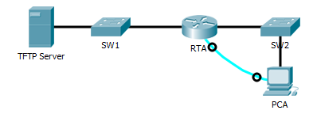
Objectives
Part 1: Establish Connectivity to TFTP Server
Part 2: Transfer Configuration from TFTP Server
Part 3: Backup Configuration and IOS to TFTP Server
Background / Scenario
This activity is designed to show how to restore a configuration from a backup and then perform a new backup. Due to an equipment failure, a new router has been put in place. Fortunately backup configuration files have been saved to a Trivial File Transfer Protocol (TFTP) Server. You are required to restore the files from the TFTP Server to get the router back online with as little down time as possible.
Part 1: Establish Connectivity to the TFTP Server
Note: Because this is a new router, initial configuration will be performed using a console connection to the router.
a. Click PCA, then the Desktop tab, followed by Terminal to access the RTAcommand line.
b. Configure and activate the Gigabit Ethernet 0/0 interface. The IP address should match the default gateway for the TFTP Server.
c. Test connectivity to TFTP Server. Troubleshoot, if necessary.
Part 2: Transfer Configuration from the TFTP Server
a. From privileged EXEC mode, issue the following command:
Router# copy tftp running-config
Address or name of remote host []? 172.16.1.2
Source filename []? RTA-confg
Destination filename [running-config]? <cr>
The router should return the following:
Accessing tftp://172.16.1.2/RTA-confg...
Loading RTA-confg from 172.16.1.2: !
[OK - 785 bytes]
785 bytes copied in 0 secs
RTA#
%SYS-5-CONFIG_I: Configured from console by console
RTA#
b. Issue the command to display the current configuration. What changes were made?
c. Issue the appropriate show command to display the interface status. Are all interfaces active?
d. Correct any issues related to interface problems and test connectivity.
Part 3: Backup Configuration and IOS to TFTP Server
a. Change the hostname of RTA to RTA-1.
b. Save the configuration to NVRAM.
c. Copy the configuration to the TFTP Server using the copy command:
RTA-1# copy running-config tftp:
Address or name of remote host []? 172.16.1.2
Destination filename [RTA-1-confg]? <cr>
d. Issue the command to display the files in flash.
e. Copy the IOS in flash to the TFTP Server using the following command:
RTA-1# copy flash tftp:
Source filename []? c1900-universalk9-mz.SPA.151-4.M4.bin
Address or name of remote host []? 172.16.1.2
Destination filename [c1900-universalk9-mz.SPA.151-4.M4.bin]? <cr>

